Trigonometric Ratios- Questions
May 2019 Mathematics Advanced Paper 1: Pure Mathematics 1

n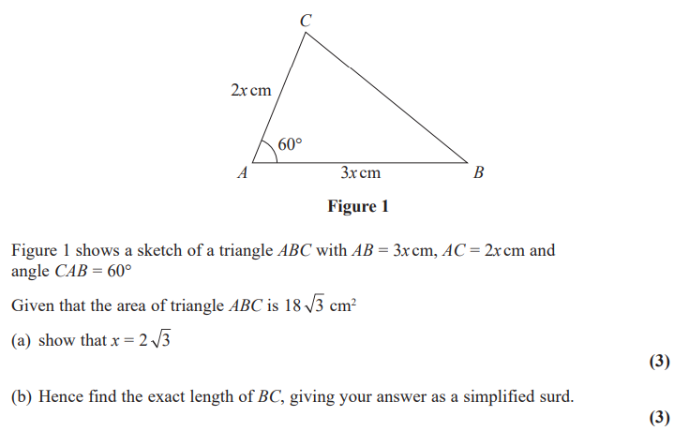
May 2018 Mathematics Advanced Paper 1: Pure Mathematics 1

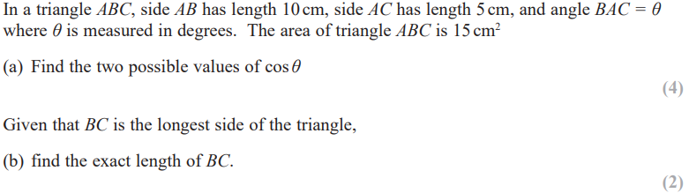
May 2017 Mathematics Advanced Paper 1: Pure Mathematics 2

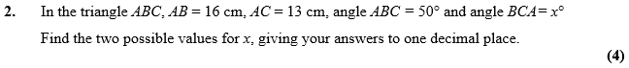
Jan 2011 Mathematics Advanced Paper 1: Pure Mathematics 2

